**DAILY ONLINE ACTIVITIES SUMMARY**

|  |  |  |  |  |  |  |  |  |
| --- | --- | --- | --- | --- | --- | --- | --- | --- |
| **Date:** | **23/05/2020** | | | | | **Name:** | **AMRUTHA G** | |
| **Sem & Sec** | **4&A** | | | | | **USN:** | **4AL18CS006** | |
| **Online Test Summary** | | | | | | | | |
| **Subject** | | **DATA COMMUNICATION(18CS46)** | | | | | | |
| **Max. Marks** | | **30** | | **Score** | | | **26** | |
| **Certification Course Summary** | | | | | | | | |
| **Course** | **DIGITAL MARKETING COURSE** | | | | | | | |
| **Certificate Provider** | | | **Great learning** | | **Duration** | | | **2.5 hours** |
| **Coding Challenges** | | | | | | | | |
| **Problem Statement1: Write a C program to generate first N Triangular Numbers(Where N is read from keyboard)** | | | | | | | | |
| **Status:Executed** | | | | | | | | |
| **Uploaded the report in Github** | | | | | **YES** | | | |
| **If yes Repository name** | | | | | **https://github.com/AMRUTHAGANESH/lockdown-codings** | | | |
| **Uploaded the report in slack** | | | | | **YES** | | | |

Online Test summary : DATA COMMUNICATION test was scheduled from 9:15 am to 9:45 am and the syllabus for the exam was 1st and 2nd module. There were 30 questions and 30 minutes.

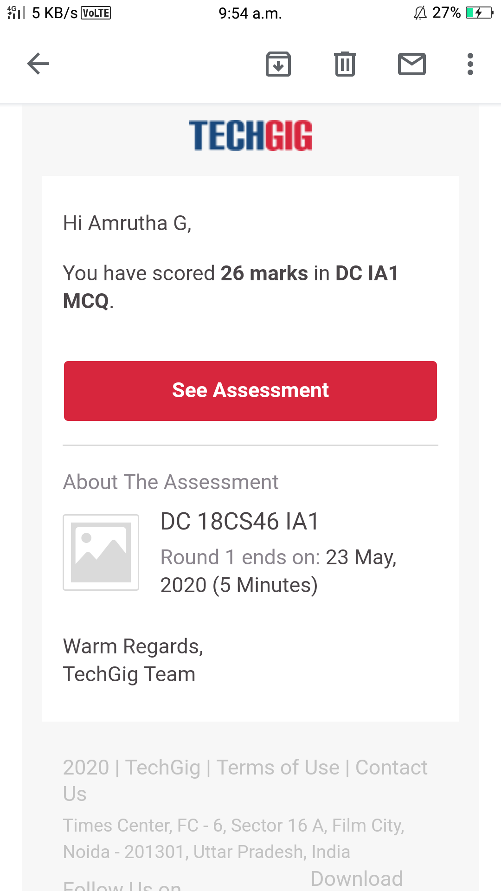

Certification Course Details: digital marketing

Today I learnt 2 modules and 3rd module

1.Explaination of new medias

2.Explaination of new medias-contd

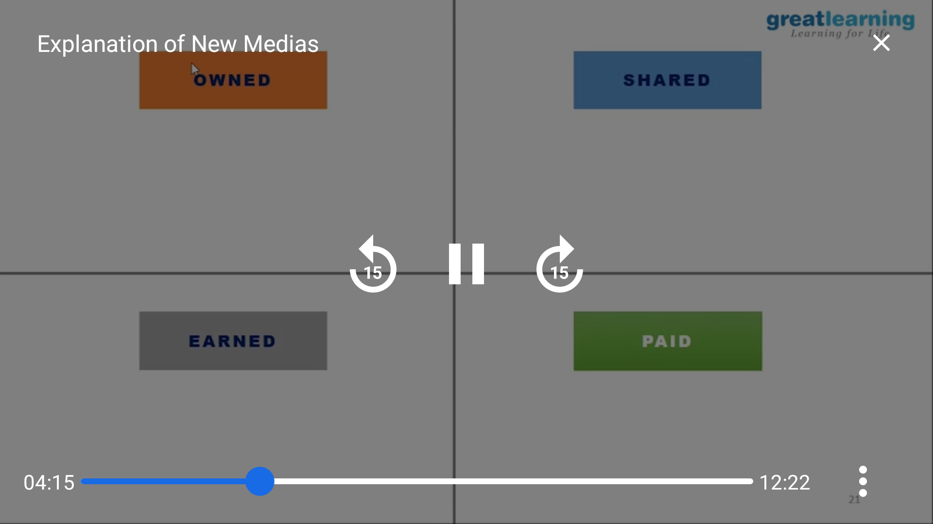

2nd



Coding Challenges Details:

PROBLEM STATEMENT: Write a C program to generate first N Triangular Number

